

COAL Project Report

Math Library

# Members:

## Aqib Ali (21K-4518)

## Khalid Khurshid Siddiqui (21K-4673)

# Introduction:

The aim is to develop a library for assembly language that would cover basic and some advance functions of mathematics which would eventually help the fellow developers pursuing assembly language (x86). Irvine32 is a library that we extensively use while using assembly language. It consists of all basic’s functions required for development, similarly this math library will aim to satisfy almost all basic mathematical needs in an easier and simplistic way.

# Background:

While programming in assembly language, we felt that there are no such external libraries in assembly language that could be used, by calling predefined functions to do simple tasks. Especially mathematical tasks were complicated and required time as we had written everything from scratch. Hence, we decided to create a Mathematics library; therefore, we browsed through the internet to gather what functions maybe include in the library and try our best to compiled them into a file.

# Project Specification:

The project consists of several mathematical functions that can be called directly through the driver function (main) while passing some values to it. The project is generic.

# Timeline/Breakup:

First Meeting (17 Nov,2022): In this meeting we made this road map.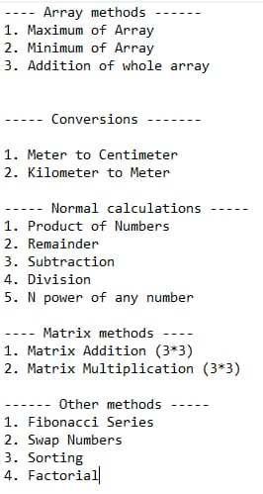

Second Meeting (1 Dec,2022): The project was Finalized, and pieces of code were combined.

# Solution Design:

1. Project Detail: We would be constructing specific procedures/functions for specific mathematical needs and would try to build it with a generic approach so there are no discrepancies.

2. Functionality: The project is offering functionality or usability in a wide range such that it is using basic arithmetic, array related and other basic or mostly used functions.

3. Features: Following is the list of functions that are available in this library:

* Array Methods:

1. Maximum of Array
2. Minimum of Array
3. Addition of Complete Array

* Conversions:

1. Meter to Centimeter
2. Kilometer to meter

* Normal Calculations:

1. Product of Numbers
2. Remainder
3. Subtraction
4. Division
5. N power of any No.

* Matrix Methods:

1. Matrix Addition (3*3)
2. Matrix Multiplication (3*3)

* Other Methods:

1. Fibonacci Series
2. Swap Numbers
3. Sorting (Bubble)
4. Factorial Calculation

Additional Features:

* GCD Calculator
* Leap Year Calculator